**eFigure 2. Hazard ratio (HR) of the rupture rate in patients with familial aneurysms compared to sporadic aneurysms adjusted for the PHASES score and smoking in cohorts defining first-degree relatives as parents, children, and siblings, analyzing the data per patient and stratified for European and Japanese populations.**

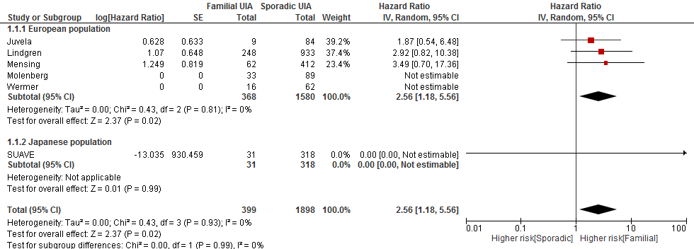

In the study from Wermer et al 1 aneurysm ruptured, in a patient with multiple aneurysms. The ruptured aneurysm was the smallest aneurysm and consequently this rupture was not included in the analysis per patient