**eFigure 5. Hazard ratio (HR) of the rupture rate in patients with familial aneurysms compared to sporadic aneurysms adjusted for the PHASES score and smoking in all studies, including those in which first-degree relatives are defined as only parents and children, but not siblings, analyzing the data per patient and stratified for European populations and Japanese populations.**

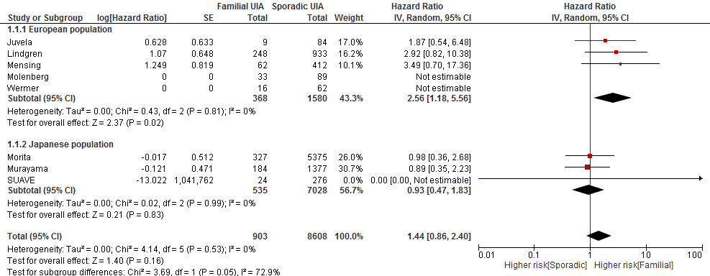

In the study from Morita et al and Murayama et al siblings were excluded in the definition of first-degree relatives.