1. Title: Simulated Falls and Daily Living Activities Dataset
2. Owners of the database

Ahmet Turan Özdemir

Phone: +90 352 207 6666 (int 32233)

Addr: Erciyes University, Electrical and Electronic Department, TR 38039, Melikgazi/Kayseri/Turkey

[aturan@erciyes.edu.tr](mailto:aturan@erciyes.edu.tr)

[www.aturan.com](http://www.aturan.com)

Billur Barshan

Phone: +90 312 290 2161

Addr: Bilkent University, Electrical and Electronic Department, TR 06800, Bilkent/Ankara/Turkey

<http://kilyos.ee.bilkent.edu.tr/~billur/>

[billur@ee.bilkent.edu.tr](mailto:billur@ee.bilkent.edu.tr)

Date: July, 2013

1. Past Usage

**\*Please cite the article numbered [1] when you use this in your work.**

[1] Özdemir, A.T.; Barshan, B. “Detecting Falls with Wearable Sensors Using Machine Learning Techniques.”, *Sensors* **2014**, *14*, 10691-10708.

Results: Six different machine learning algorithms were employed and 100% sensitivity was achieved with *k*-NN algorithm.

[2] Özdemir A.T., Orman A., " Developing an iPhone smartphone based fall detection algorithm.", IEEE, 23rd Signal Processing and Communications Applications Conference (SIU), Malatya, Turkey, 16-19 May **2015**, pp.1-4.

Results: A threshold based algorithm was developed in order to detect falls on a mobile device.

[3] Özdemir A.T., "An Analysis on Sensor Locations of the Human Body for Wearable Fall Detection Devices: Principles and Practice.", *Sensors* **2016**, *16*, 11691.

Results: Waist region was found as the best sensor placement location on the human body.

[4] Ntanasis P., Pippa E., Özdemir A.T., Barshan B., Megalooikonomou V., "Investigation of sensor placement for accurate fall detection", 6th EAI International Conference on Wireless Mobile Communication and Healthcare (MobiHealth), Milan, Italy, 14-16 Nov. **2016**, pp.1-6

Results: Waist region was found as the best sensor placement location on the human body.

1. Relevant Information:
2. Number of Instance: 3060

17 Volunteers × Avg. 5 repetitions × 36 Movements

1. Number of Attributes:

36 Movements including 20 Falls and 16 Daily Living Activities

6 Sensors each includes 3 axis Accelerometer, Gyroscope and Magnetometer.

1. Attribute Information: Xsens MTw Motion Tracking Kit
2. Missing Attribute Values: Rarely
3. Information About Data Formation:

Folder Name 1XX Male Volunteers

Folder Name 2XX Female Volunteers

Folder Name 8XX Activities of Daily Living

Folder Name 9XX Fall Actions

Each folder contain 36 class of tests, please see Table 1 [1]

20 class of FALL ACTIONS # Label and Description

901 front-lying, from vertical falling forward to the floor

902 front-protecting-lying, from vertical falling forward to the floor with arm protection

903 front-knees, from vertical falling down on the knees

904 front-knees-lying, from vertical falling down on the knees and then lying on the floor

905 front-quick-recovery, from vertical falling on the floor and quick recovery

906 front-slow-recovery, from vertical falling on the floor and slow recovery

907 front-right, from vertical falling down on the floor, ending in right lateral position

908 front-left, from vertical falling down on the floor, ending in left lateral position

909 back-sitting, from vertical falling on the floor, ending sitting

910 back-lying, from vertical falling on the floor, ending lying

911 back-right, from vertical falling on the floor, ending lying in right lateral position

912 back-left, from vertical falling on the floor, ending lying in left lateral position

913 right-sideway, from vertical falling on the floor, ending lying

914 right-recovery, from vertical falling on the floor with subsequent recovery

915 left-sideway, from vertical falling on the floor, ending lying

916 left-recovery, from vertical falling on the floor with subsequent recovery

917 rolling-out-bed, from lying, rolling out of bed and going on the floor

918 podium, from vertical standing on a podium going on the floor

919 syncope, from standing falling on the floor following a vertical trajectory

920 syncope-wall, from standing falling down slowly slipping on a wall

16 class of Non-Fall Actions (ADLs) # Label and Description

801 walking-fw, walking forward

802 walking-bw, walking backward

803 jogging, running

804 squatting-down, squatting, then standing up

805 bending, bending about 90 degrees

806 bending-pick-up, bending to pick up an object on the floor

807 limp, walking with a limp

808 stumble, stumbling with recovery

809 trip-over, bending while walking and then continuing walking

810 coughing-sneezing, coughing or sneezing

811 sit-chair from vertical, to sitting with a certain acceleration onto a chair (hard surface)

812 sit-sofa from vertical, to sitting with a certain acceleration onto a sofa (soft surface)

813 sit-air from vertical, to sitting in the air exploiting the muscles of legs

814 sit-bed from vertical, to sitting with a certain acceleration onto a bed (soft surface)

815 lying-bed, from vertical lying on the bed

816 rising-bed, from lying to sitting

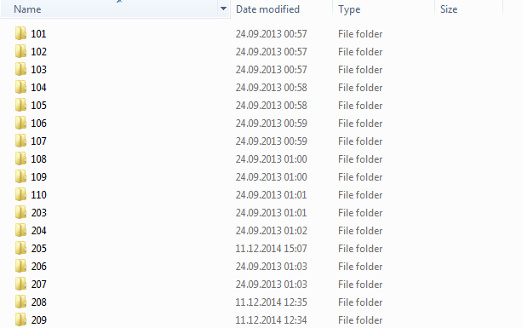

Figure 1: Database includes 10 male and 7 female volunteers’ data

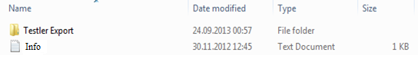

Figure 2: “Testler Export” folder contains activity records; “Info.txt” is information file of the individual volunteer.

Info.txt file contains information about volunteer as below.

GENDER

WEIGHT (KG)

HEIGHT (CM)

AGE

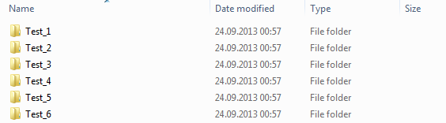

Figure 3: Each activity contains at least 5 tests some of activities contain 6 tests.

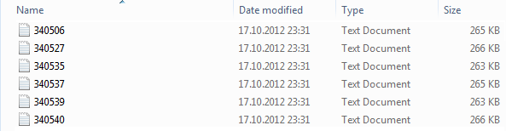

Figure 4: Each test contains 6 sensors’ data.

Each sensor has individual code as below please see Figure 1 in [1].

340506 Head sensor

340527 Chest sensor

340535 Waist sensor

340537 Right wrist sensor

340539 Right thigh sensor

340540 Right ankle sensor

We use volunteers of 101, 102, 103, 104, 106, 107, 108, 203, 204, 205, 206, 207, 208, 209 in [1]

Each sensor record *.txt data file contains 23 columns are Counter, Temperature, VelInc_X, VelInc_Y, VelInc_Z, OriInc_w, OriInc_x, OriInc_y, OriInc_z, Acc_X, Acc_Y, Acc_Z, Gyr_X, Gyr_Y, Gyr_Z, Mag_X, Mag_Y, Mag_Z, Pressure, Roll, Pitch, Yaw, RSSI respectively.

Please check MTw data types via <https://www.xsens.com/products/mtw-development-kit-lite/>